

**Artificial Intelligence and Data Science Department.**

OS / Even Sem 2021-22 / Experiment 5.

**___________________________________________________**

YASH SARANG.

47 / D6AD.

EXPERIMENT - 5.

System Calls 2

**___________________________________________________**

**Aim:** Extend the above experiment to explore the following system calls: open, read, write, close, getpid, setpid, getuid, getgid, getegid, geteuid.

**___________________________________________________**

**Theory:**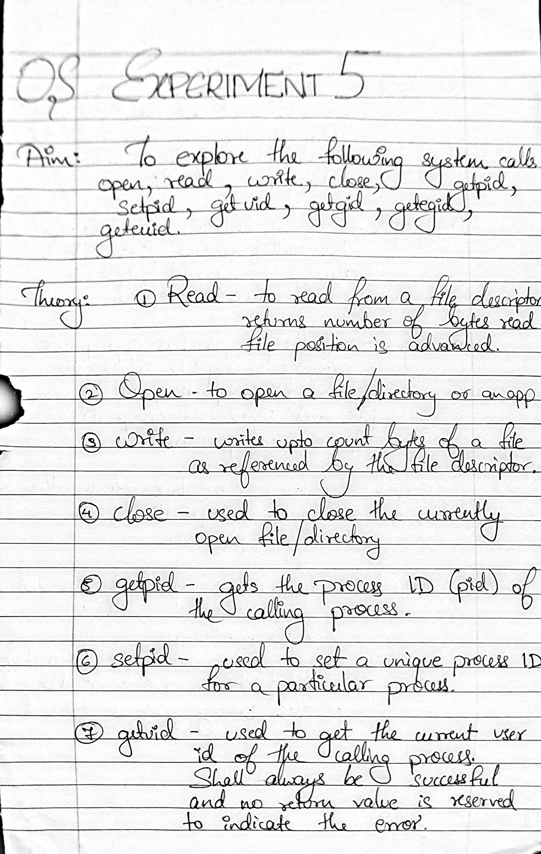

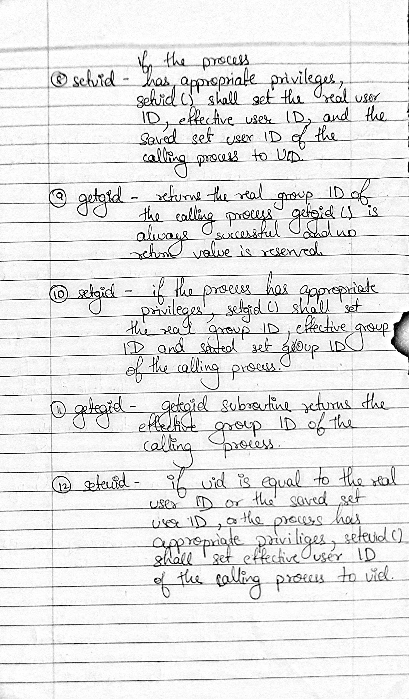**___________________________________________________**

**Code:**

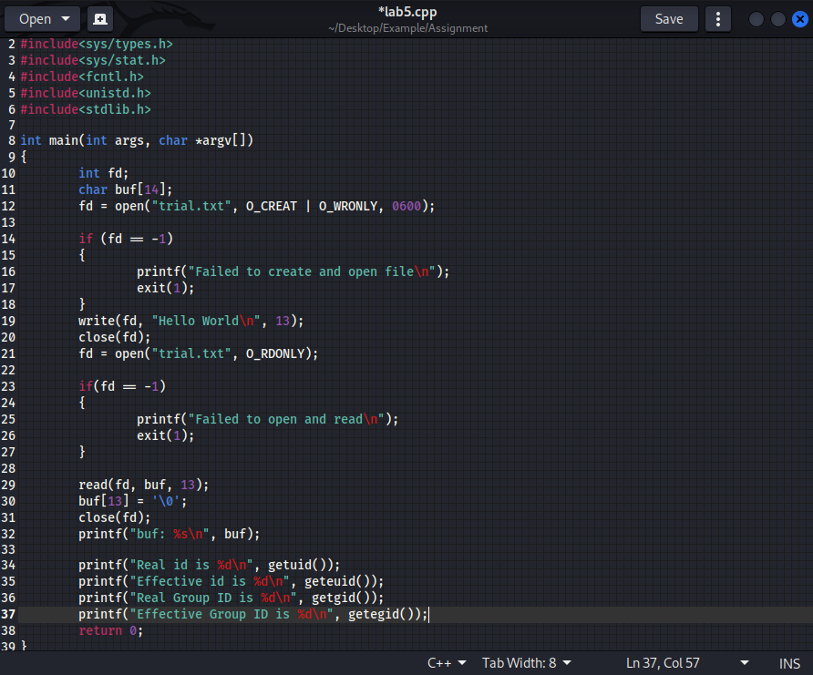

**___________________________________________________**

**Snippets:**

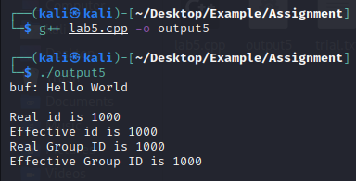

**___________________________________________________**

Conclusion:-

Thus we can use the above commands and have learned in-depth about them.

**___________________________________________________**